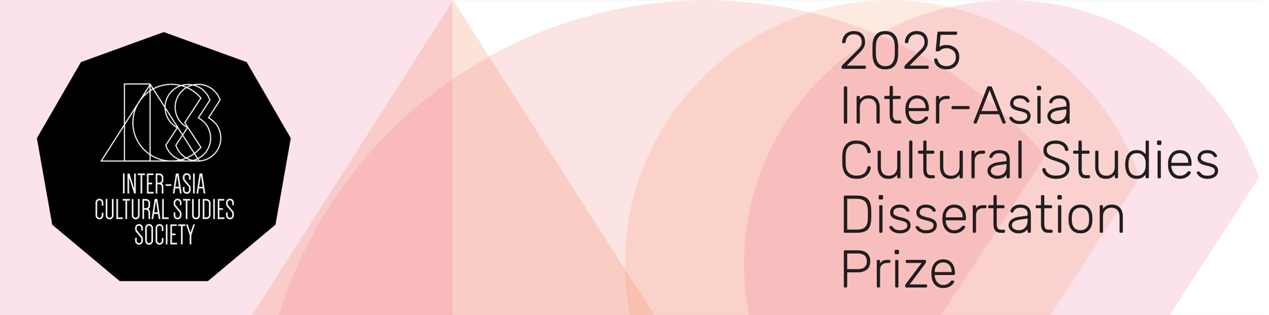

Nomination Form for the IACSS Dissertation Prize

We accept nominations of Ph.D. candidates or recent graduates whose final dissertations (i.e. fully completed dissertations that have already gone through all review, defence/viva, and revision stages) have been or will be submitted to their institutions between 1 August 2023 and 30 April 2025 (this is irrespective of whether nominees have already been formally awarded their degrees). In the case of nominees who have not yet formally been awarded their degrees, and who have passed our initial screening stage, proof of official dissertation submission needs to be presented by 30 April 2025. We accept Ph.D. dissertations written in both English and other Asian languages.

The submission for the prize should include the nomination form, an extended abstract in English (1000 words), and the first chapter of the dissertation. Please send the required documents to interasiaculturalstudies@gmail.com by 31 January 2025. Only candidates who have passed an initial IACS Society screening will be asked to submit their complete dissertations by February 2025. These dissertations will be reviewed by the dissertation prize jury, and the decision will be announced in May 2025.

Applicant’s Information
Name
Affiliation
Email
Dissertation Title
Full completed and revised Ph.D. dissertation submitted (or expected to be submitted) on
Nominator’s Information
Name
Affiliation
Email
Relationship to Applicant

Reasons for Nomination
We ask the nominator to address the following questions: How does the dissertation engage with the Inter-Asia problematics and methodologies, and how does it advance the knowledge production of Asia on the local, regional, and/or transnational registers? (Please keep the nomination to two pages.)

