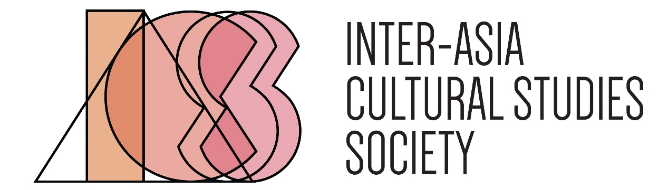

Nomination Form for the IACSS Dissertation Prize
We accept dissertations written in both English and the Asian languages. The complete submission for the prize should include the nomination form, an extended abstract in English (1000 words), and the first chapter of the dissertation. Please kindly send these documents to interasiaculturalstudies@gmail.com by February 28, 2023. Only candidates who have passed the initial screening will be asked to submit the complete dissertation.

Applicant’s Information
Name
Affiliation
Email
Dissertation Title
Ph.D. Expected in
Nominator’s Information
Name
Affiliation
Email
Relationship to Applicant

Reasons for Nomination
We ask the nominator to address the following questions: How does the dissertation engage with the Inter-Asia problematics and methodologies, and how does it advance the knowledge production of Asia on the local, regional, and/or transnational registers? (Please keep the nomination to two pages.)

