Practical Information

- Reimbursement
Your travel costs including airfare and train to Gwangju(광주) will be reimbursed by Asian Culture Center. Following some paperwork, the sum will be transferred to your bank account (not paid by cash). It will take more or less one month after the conference.

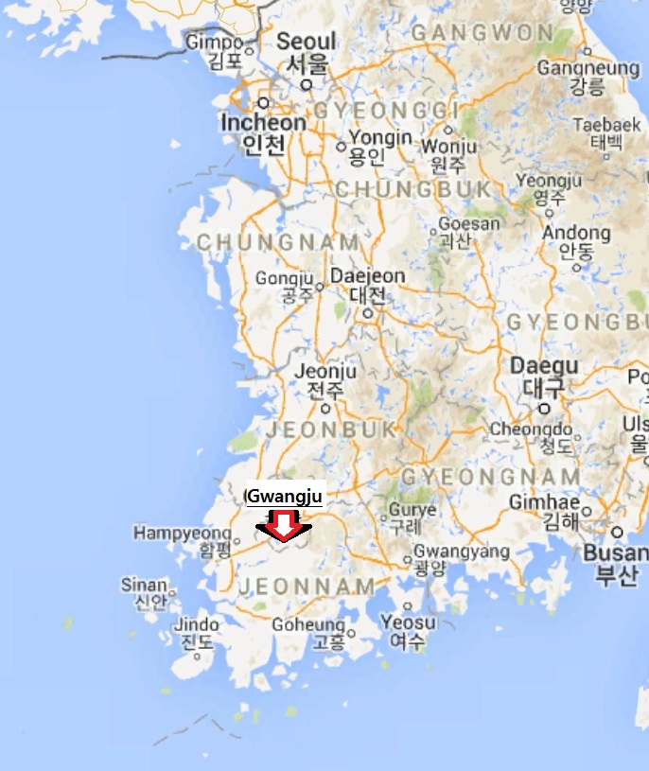

- How To Get To The Hotel
The bottom line is that the journey could involve changing trains as many as four times unless you are incredibly fortunate with timing. Please follow the instruction below carefully.

- The best route:
When you got out of the arrival gate in Incheon Int’l Airport,

- Go to the train ticket office located between gates 8 and 9.
- Buy a single ticket for KTX (Korean Train Express) to Gwangju-Songjeong (광주송정). There are two trains a day from Incheon Airport to Gwangju-Songjeong.
Train No. | Departure time  (Incheon Airport) | Arrival time  (Gwangju-Songjeong) | Adult Fare  (KRW/USD)
KTX-513 | 9:38 | 12:26 | 1st Class: 83,200/72  Standard Class: 59,400/52  Standing: 50,500/44
KTX-525 | 15:50 | 18:44
- If you find that you can take one of these trains, take it by all means. KTX station is located in 1st basement of Incheon Int’l Transportation Center. There is no specific turnstile for KTX ticket.
- After about 3 hours, get off the train at Gwangju-Songjeong train station.
- Go to Gwangju-Songjeong Station (광주송정역) metro station. The metro (subway) station is just outside the KTX train station, but you need to buy a separate ticket.
- Buy a metro ticket using the ticket vending machine near turnstiles. It costs KRW 1,100 (USD 1). And take a metro in direction to Songjeong Park (송정공원) (The final station is Nokdong (녹동) station). Do NOT take the train to Dosan or Pyeongdong (도산, 평동) station).
- After about 30 minutes passing 12 stations, get off the train at Culture Complex (문화전당, Moonhwajeondang) station.
- Get out of the station through Exit 3, and go straight 430m on the left side of Seoseok-ro (서석로) Street (heading to the West) and turn left onto Seoseok-ro 10 Beon-gil (서석로10번길). Then go straight about 80m until you see a hotel called “Hiddink Hotel” on the left side.
- At (5), alternately, you can take a taxi from Gwangju-Songjeong train station to Hiddink hotel. It costs 16,000 – 20,000 KRW (approx. 15-19 USD). If you are more than one person and your bags are heavy, it can be an option though pricey. 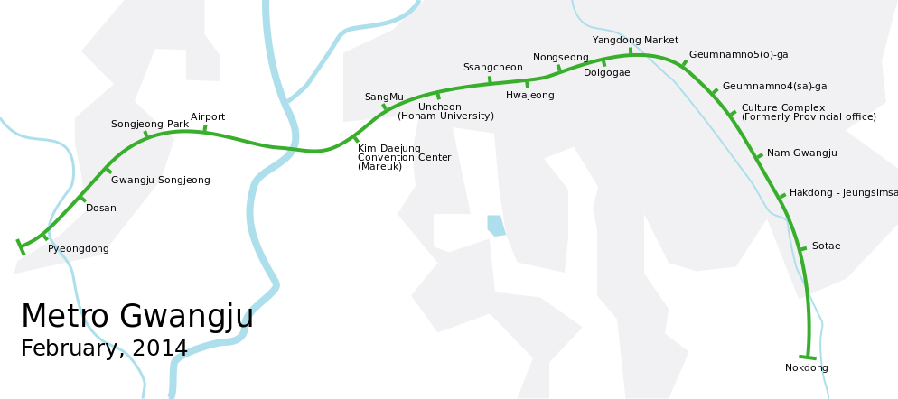

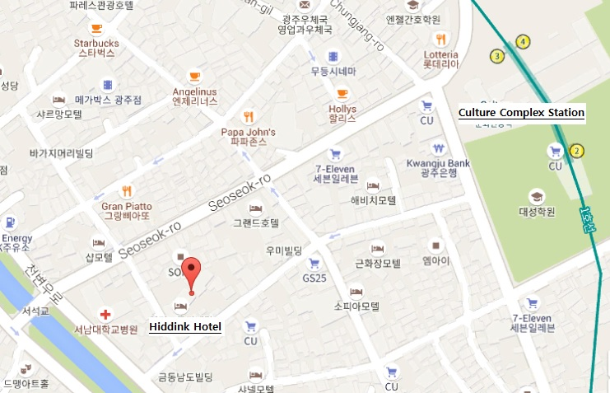

- The second best but most likely route:
- Overview
When you got out of the arrival gate in Incheon Airport, go to the train ticket office located between gates 8 and 9. Even though the direct train is not available, you can book two tickets in advance: from Incheon Airport Station to Seoul Station (Airex), and from Yongsan Station to Gwangju-Songjeong Station. But, you still need to separate metro tickets between two journeys (in Seoul) and from Gwangju-Songjeong Station to Culture Complex Station (in Gwangju). Below are the details when you don’t use the ticket office and travel like a local.
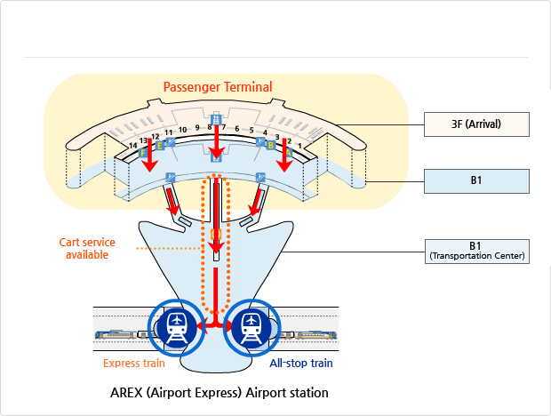
- Go to the Express Train Information Center on 1st basement of Incheon Int’l Transportation Center and buy a ticket (KRW 8,000/USD 7).
- Go to the AREX (Airport Express) Airport station and take an Express train not an All-stop train (because it takes longer and less convenient).
- Express Train runs nonstop between Incheon Int’l Airport and Seoul Station (서울역). Make sure the trains run here infrequently and check out the timetable below.
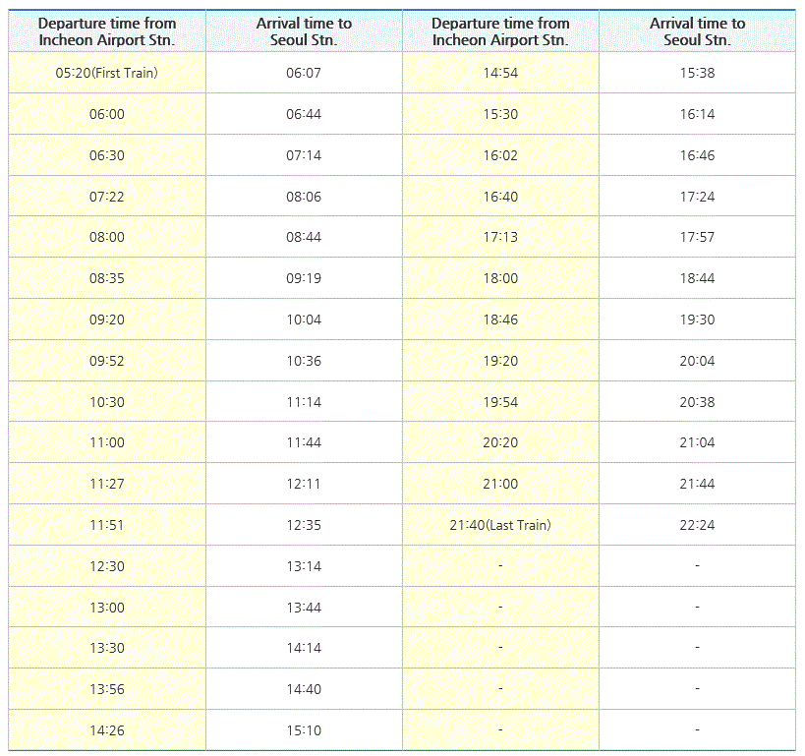
- When you arrive at Seoul Station after 44 minute journey, get off the train and go to Seoul Station (서울역) metro station to get to Yongsan (용산) station by taking the blue line or Line No.1 (1호선).
- Buy a Single Journey Card using the ticket vending machine. As the card is disposable, you should deposit KRW 500 won at the time of its purchase. From Seoul Station to Yongsan, it costs KRW 1,250 (USD 1) by metro. So you will pay KRW 1,750 at the vending machine (the deposit is refundable on returning the care to the machine after your journey.
- Take a metro train at Seoul Station metro station Line No. 1 in direction to Namyoung (남영) station (not to City Hall (시청) station).
- After 6 minutes passing just 1 station (Namyoung station), get off at Yongsan station.
- Getting out of the metro station, don’t forget to return your Single Journey Card to a deposit refund device. Then you may receive a 500 won refund.
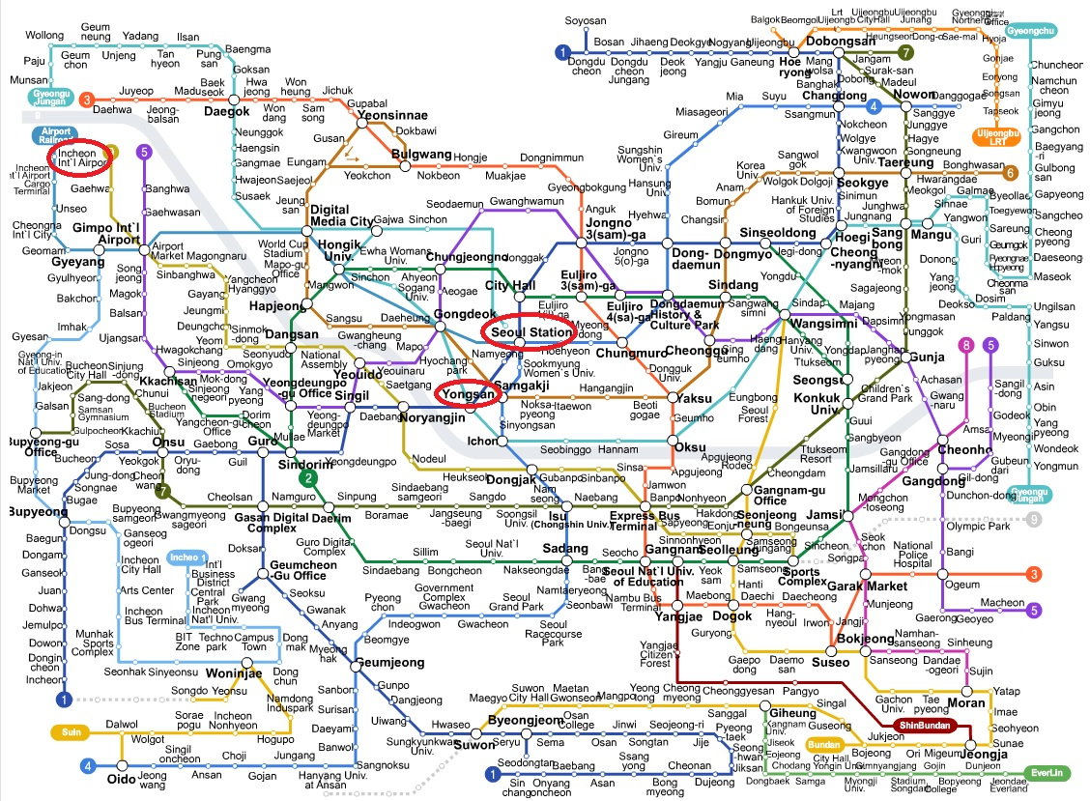
- At ticket office or using ticket machine, buy a single ticket of KTX train to Gwangju-Songjeong station. The KTX trains run 1~2 times per hour from 5AM to 10PM. (Adult fare(KRW/USD): 1st Class 65,500/57, Standard Class 46,800/40, Standing 39,800/34)
- Take KTX train at Yongsan station. There is no specific turnstile for KTX ticket. And after about 2 hours, get off the train at Gwangju-Songjeong station.
- Follow the steps five to eight from the first case.

* For your information, here are a couple of useful websites:
- Hiddink Hotel: http://www.hiddinkhotel.com/_eng/
- Korail: http://www.letskorail.com/ebizbf/EbizBfTicketSearch.do (if you want to book your train in advance online)
- AREX: http://www.arex.or.kr/content.do?url=&menuNo=MN201503300000000001&contentNo=&clientLocale=en_US&clientDevice=Normal
- Visit Korea: http://english.visitkorea.or.kr/enu/TR/TR_EN_5_1_4.jsp (information about using metro)

- Accommodation
Hiddink Hotel – close to Culture Complex (the conference venue), a room for each, breakfast not included (You could buy yourself breakfast at the hotel restaurant if you want)

- Meals
Lunch and dinner provided by Asian Culture Center on 4 Dec.

- Optional but Recommended
- I recommend you to rent a mobile phone or ‘egg’ (for wi-fi connection) at the airport. It is just beside KTC train ticket office. It would be the most desirable to contact by facebook messenger. Mine is ‘hyunjoon.shin’ and Keewoong’s ‘keewlee.’
- There is unofficial dinner among the participants. Let’s meet at 7:30 pm at the hotel lobby. It is because one train from Incheon Airport arrives 18:44 at Gwangju-Songjeong Station. But we shoud ‘go Dutch’, as there is no extra budget.
- In case of emergency, belwo are the phone numbers
Keewoong Lee +82(0)1047649925 (int’l) / 01047649925 (local)
Doowan Kim +82(0)1091497042 (int’) / 01091497042 (local)
Mijug Kim (ACC) +92(0)1092085047 (int’l) / 01092085047 (local)
Hyunjoon Shin: +82(0)1027323241 (int’l) / 01027323241 (local)

- Below are the tags in case you take taxi and communicate with the drivers.
히딩크호텔로 태워 주세요.  Take me to Hiddink Hotel.  광주시 동구 불로동 160-1  160-1 Bullo-dong, Dong-gu, Gwangju  Tell: 062-227-8500 | 내 한국인 친구 이기웅에게 전화를 걸어주세요.  Call to my Korean friend Keewoong Lee  010 4764 9925

